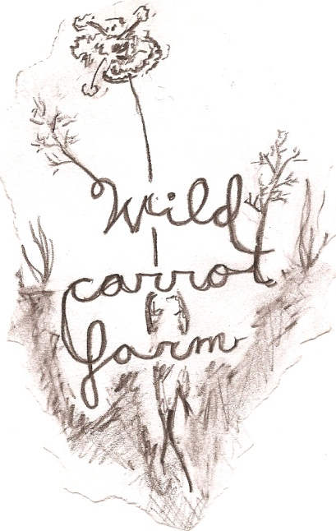

Dear Chef,

I am writing to introduce Wild Carrot Farm to your restaurant and find out how we might provide you with a source of local, organic produce this year. We are a small, diversified organic farm raising vegetables, eggs, and meat in Brookline and Newfane. We are committed to selling 100% of our food locally, and using only the strictest organic standards to maintain the health of our land and our customers. Our goal is to produce the highest quality food possible at reasonable prices.

In preparation for planning our planting schedule, we are hoping you can tell us what sorts of produce you might purchase from us. I’m enclosing a list of what we can grow and the timeframe within which we can offer it. We’re not looking for a commitment, but if we can gauge your interest and understand what you might use, we can buy seed and plant accordingly so we can serve you better this spring.

Thank you for considering our produce and for helping us create a viable, small farm in Windham County. If you have more questions please feel free to call me anytime at 365-4075. I look forward to talking to you soon.

Sincerely,

Jesse Kayan
Wild Carrot Farm
14 Grout Rd
Newfane, VT 05345
wildcarrotfarm@gmail.com
www.wildcarrotfarm.net

Wild Carrot Farm
2011 Produce Availability

Please check what items you might be able to purchase and list in what quantity (per week). We will be emailing a list of available produce each week. You can place an order and the produce will be delivered within 24 hours of being picked.

Restaurant____________________________ Contact Person ____________________________

Best days for produce delivery_____________________________________________________

- Arugula: June - October
- Beans: July-September
- Beets: June-October
- Broccoli: June-July, Sept.-Oct.
- Cabbage: July-October
- Cauliflower: June-July, Sept.-Oct.
- Celery: July-October
- Celeriac: August-October
- Carrots: June-October
- Collards: June-October
- Corn: July-September
- Cucumbers: July-September
- Eggplant: July-September
- Endive: June-October
- Fennel: July-September
- Garlic: July-October
- Herbs: June-October dpndg. on vrty.
- Husk Cherry: July-October
- Kale: June-October
- Leeks: August-October

- Onions: August-October
- Lettuce: June-October
- Mesclun: June-October
- Mustards: June-October
- Melon: August-October
- Parsnips: June, September-October
- Peas: June-July, September-October
- Peppers: August-October
- Potatoes: July-October
- Radishes: June-October
- Scallions: June-October
- Spinach: June-July, Sept.-Oct.
- Sprouts: June-October
- Summer squash: July-September
- Swiss chard: June-October
- Tomatoes: July-September
- Turnips: June-October
- Winter squash: August-October
- Zuchinni: July-September

